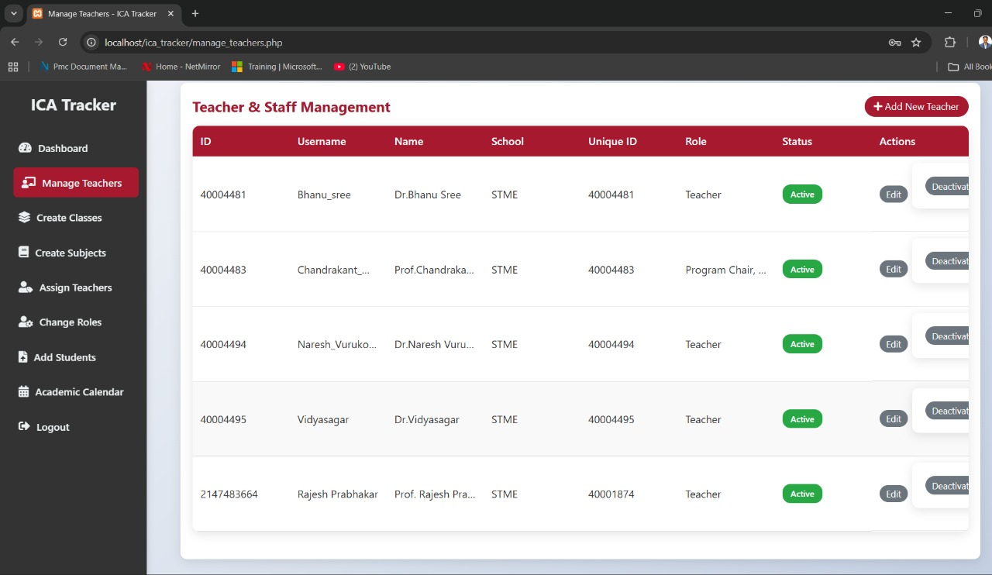
Remove id column from manage_teachers

2. Invalid CSV format. Required columns missing: SNO. Please use the template.
S/N is the required column not SNO

3. 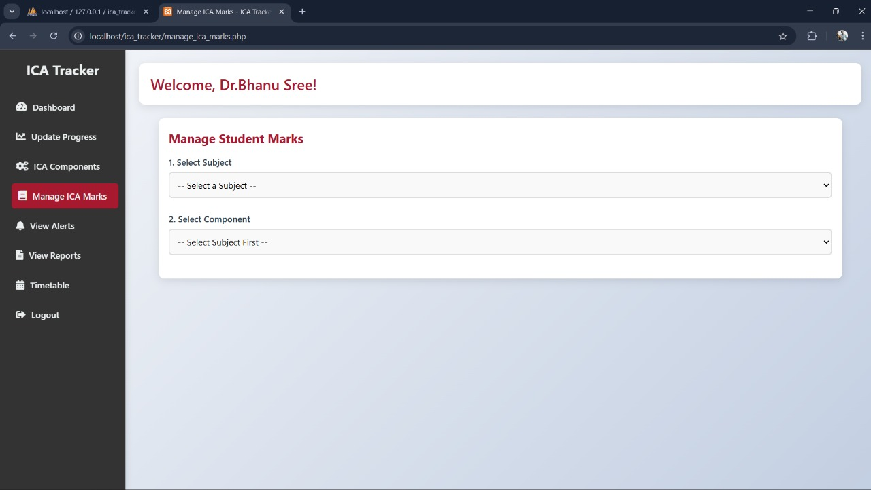
also here they can select multiple components by Ctrl + click mention a note here and tell that info so that while uploading a csv they can easily upload it and also make sure required four columns + selected components name (Mid Exam 1, Mid Exam 2 Like this )

4. 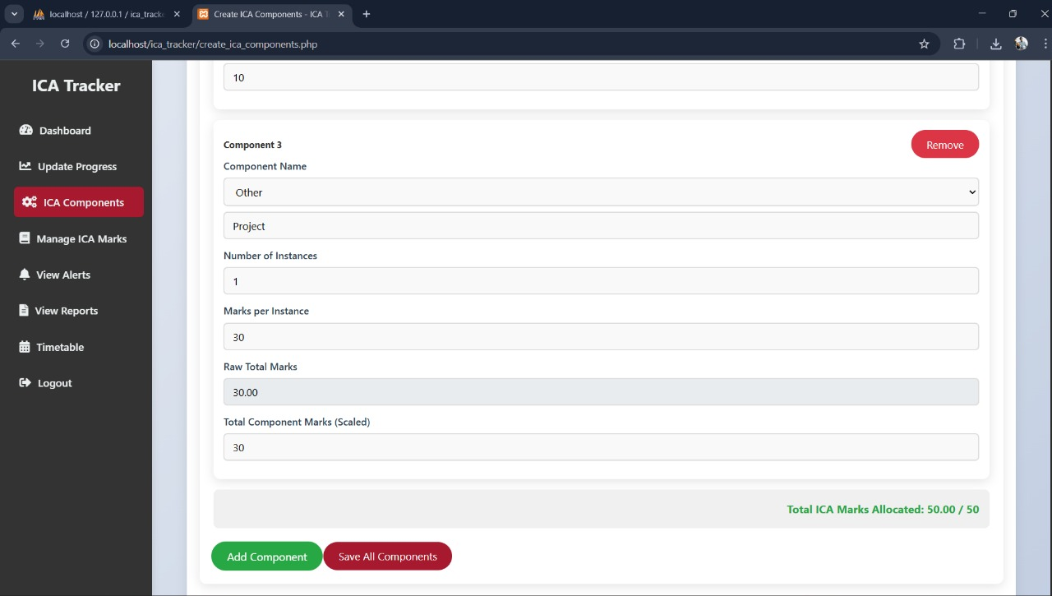
here also 1 alert or popup should come if you are adding more marks than 50 alert should come

5. 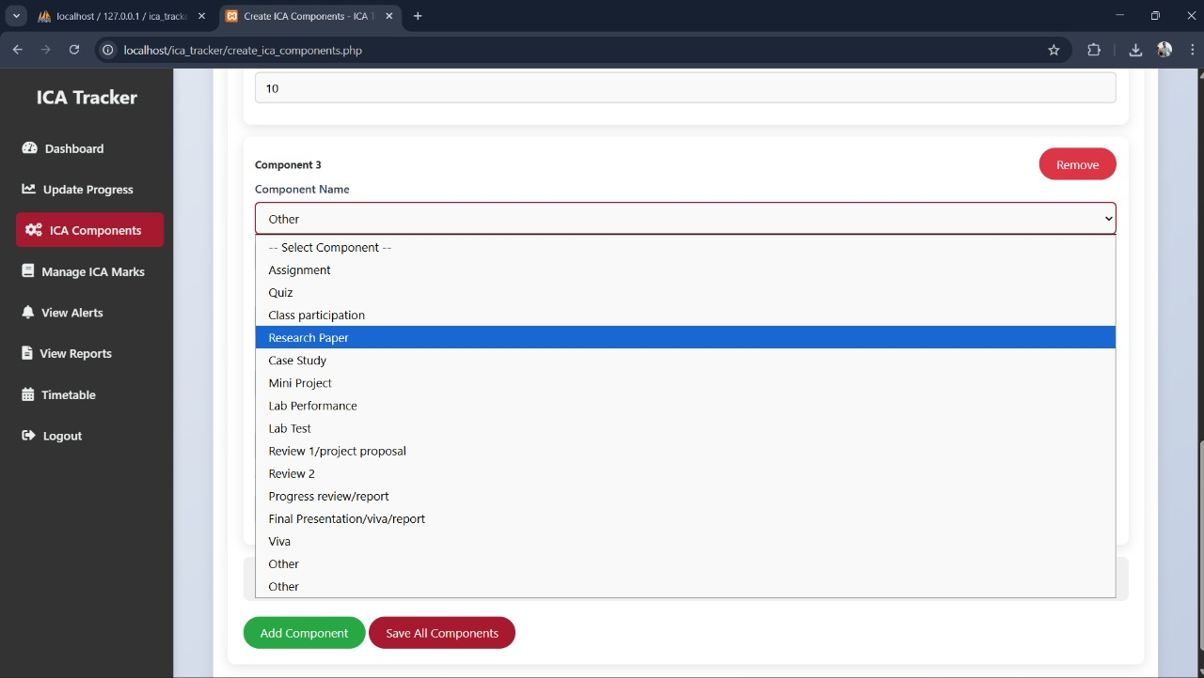
Two others are showing in the ica components
only one other should come and after clicking other component name box will come don’t change this functionality
6.
Welcome, Dr.Bhanu Sree!

this name should be shown only in the Teacher dashboard and admin dashboard only not in all pages in other pages it should show the page details as heading like
Teacher Progress Analysis
Student Progress Analysis

this should be the headings except the dashboard in the dashboard it should show like
Welcome + name!

7. 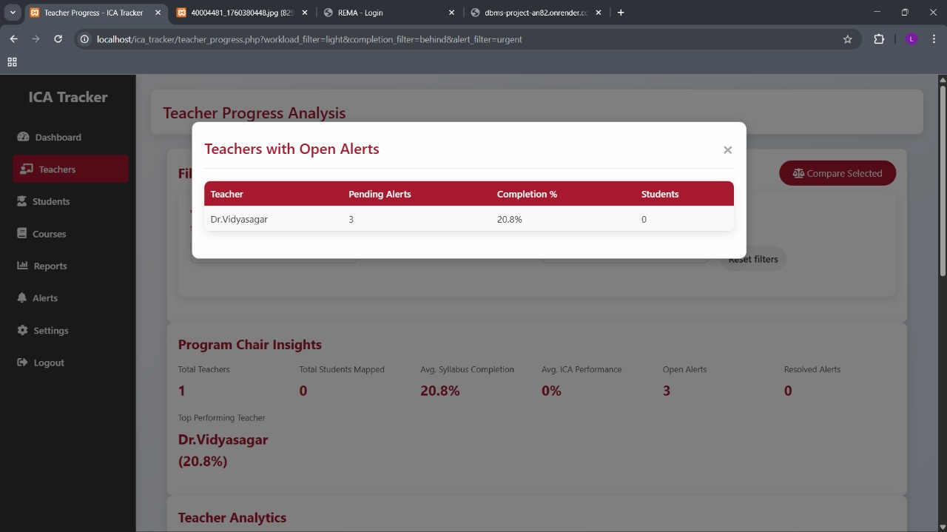
after clicking on open alerts here it was opened and after clicking on the Dr.Vidyasagar also it should show the appropriate data like this is for teachers with open alerts show by clicking on it, it should show me the alerts also accordingly

8. remove the checkbox option in the teacher progress

